St. Matthew’s Local Rule Addition to “Cal Ripken Major 60 FT. Baseball Division Special Base Running Rule”
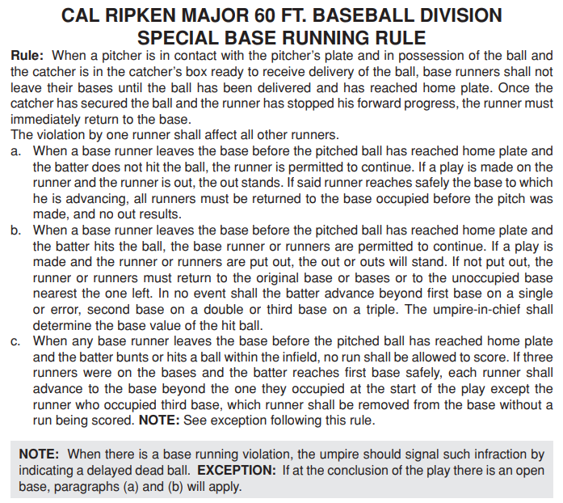

Enforcement:
-First Violation: Umpire will issue a warning for violation, as a team, and return the baserunners to the base where they began the affected play.
-Second Violation: Umpire will issue an “out” and remove the baserunner in violation of the rule.
-Third Violation: Umpire will issue an “out” and remove the baserunner in violation of the rule. Umpire will remove the head coach from the game.
Evaluation of violations and enforcement are at the umpire’s sole discretion.

Examples/Clarifications:
- Example
  - Pitcher delivers the pitch and the runner breaks from the bag when the ball crosses the plate. The catcher clearly catches the ball or has possession of the ball within the catcher’s box. The baserunner does not return to the base and instead jukes, feigns, or simply holds their position clearly off of the base (between 1st and 2nd, between 2nd and 3rd, or between 3rd and Home) with no discernable movement back to their original base. The umpire will call a violation of the base running rule/delay of game and enforce accordingly.
- Clarification
  - Once the catcher, has received the pitch and is clearly in possession of the ball and within the catcher’s box and the baserunner is not clearly progressing with intent to the next base, the play is NOT considered DEAD for the purposes of the return throw to the pitcher. If the catcher makes an errant throw to the pitcher or the pitcher drops the return throw, the baserunner who has retreated or is in the process of retreating to their original base, CAN advance on the throwing error. If in the umpire’s opinion, the baserunner was engaging in tactics meant to deceive, distract or otherwise cause an errant throw, the runner will be deemed in violation of the baserunning rule and enforcement will be applied.
  - In the event there are runners on multiple bases, each baserunner is treated individually. If a baserunner on 1st base is advancing to 2nd base on a steal, they must continue to that bag if a play is NOT being made on them. If a play IS being made on the advancing baserunner, then the ball is LIVE and play will continue and all baserunners can advance at their own risk. If any baserunners are not actively advancing to another base in this scenario, then they must retreat to their original bag if the catcher has possession of the ball.
- All Other Scenarios Not Covered
  - These will be enforced at the discretion of the umpire as with all other instances of this rule. The umpire will take into account:
    - Intent to Deceive
    - Impact on Game Play/Delay of Game Progress

